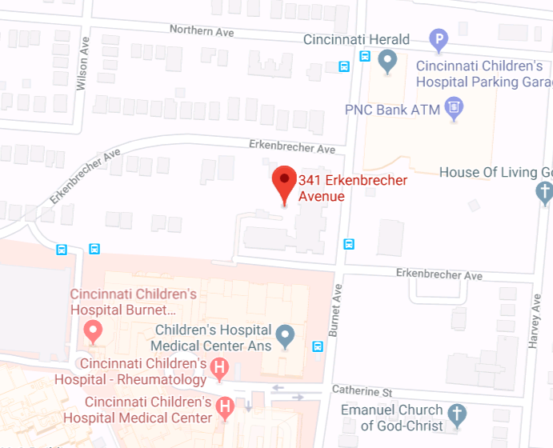

**Guest Family Parking Additional Visitor Parking**

**All Visitor Parking:**

**Northern Avenue Parking Garage**

**No Onsite Parking at RMH**

**Temporary parking only for**

**Guest Family Loading/Unloading and Donation Drop-Offs**