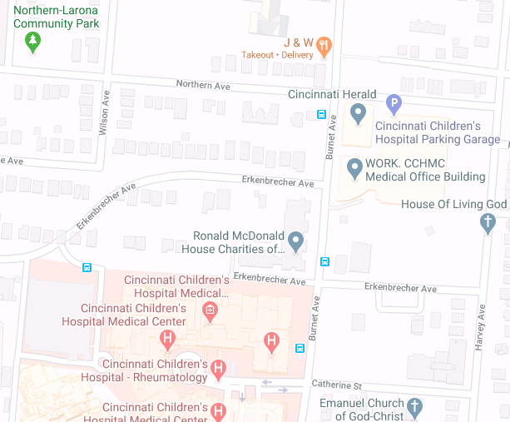

All visitor parking: Cincinnati Children’s Hospital Parking Garage on Northern Ave.
RMH Guest families: Temporary loading/unloading on Ronald McDonald House only. Parking available at Cincinnati Children’s Hospital.
Donation Drop-off: Temporary loading/unloading on Ronald McDonald House property only.

